Restrictions

Business Rule: For a faculty member to be assigned to teach a section of a course, the faculty member must be qualified to teach the course for which that section is scheduled.

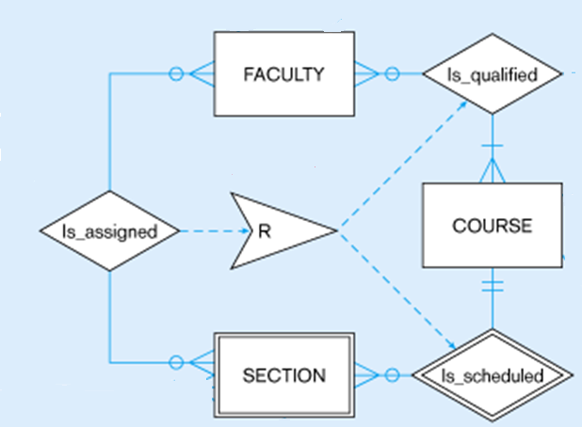

UPPER LIMIT
Students register for courses at WIT. A course will have many students. A student is not allowed to register for more than 5 courses in a semester.

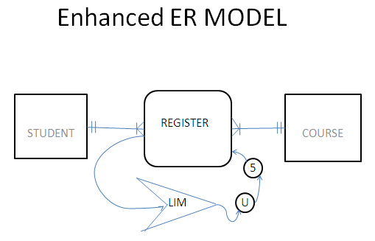

Exercise:
If each course has a maximum limit of students as 40, how do you include that fact in your Enhanced ER model. Redraw the above diagram.

Sub types and Super types

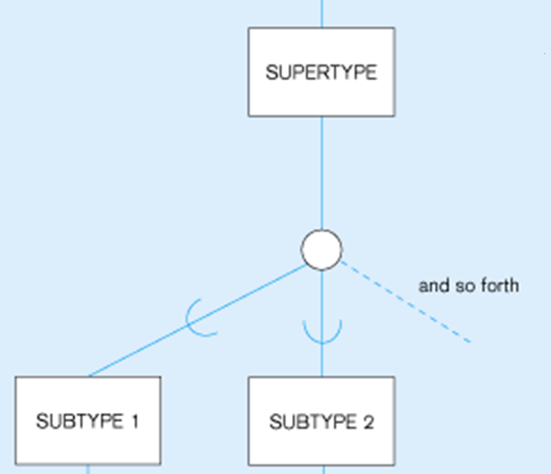

Read

http://www.slideshare.net/BlackIce86/modern-database-management-jeffrey-a-hoffer-mary-b-prescott (page 151)

Why do the following sub-types different?

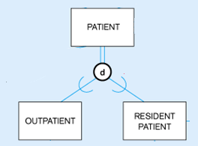
Why double lines here?
Why d here?

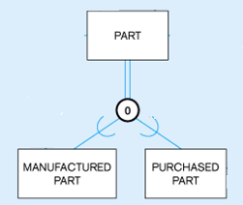
Why o here?

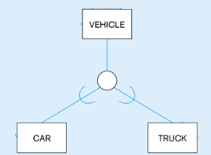
Why single line here?
Read : Page 143 – 157 in your Text Book (8 Ed.)

